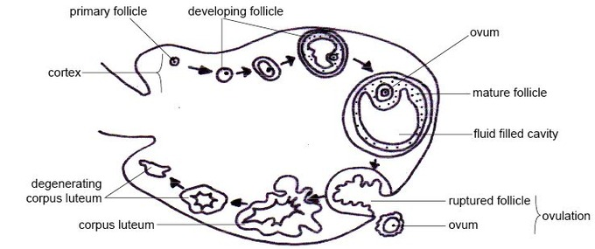
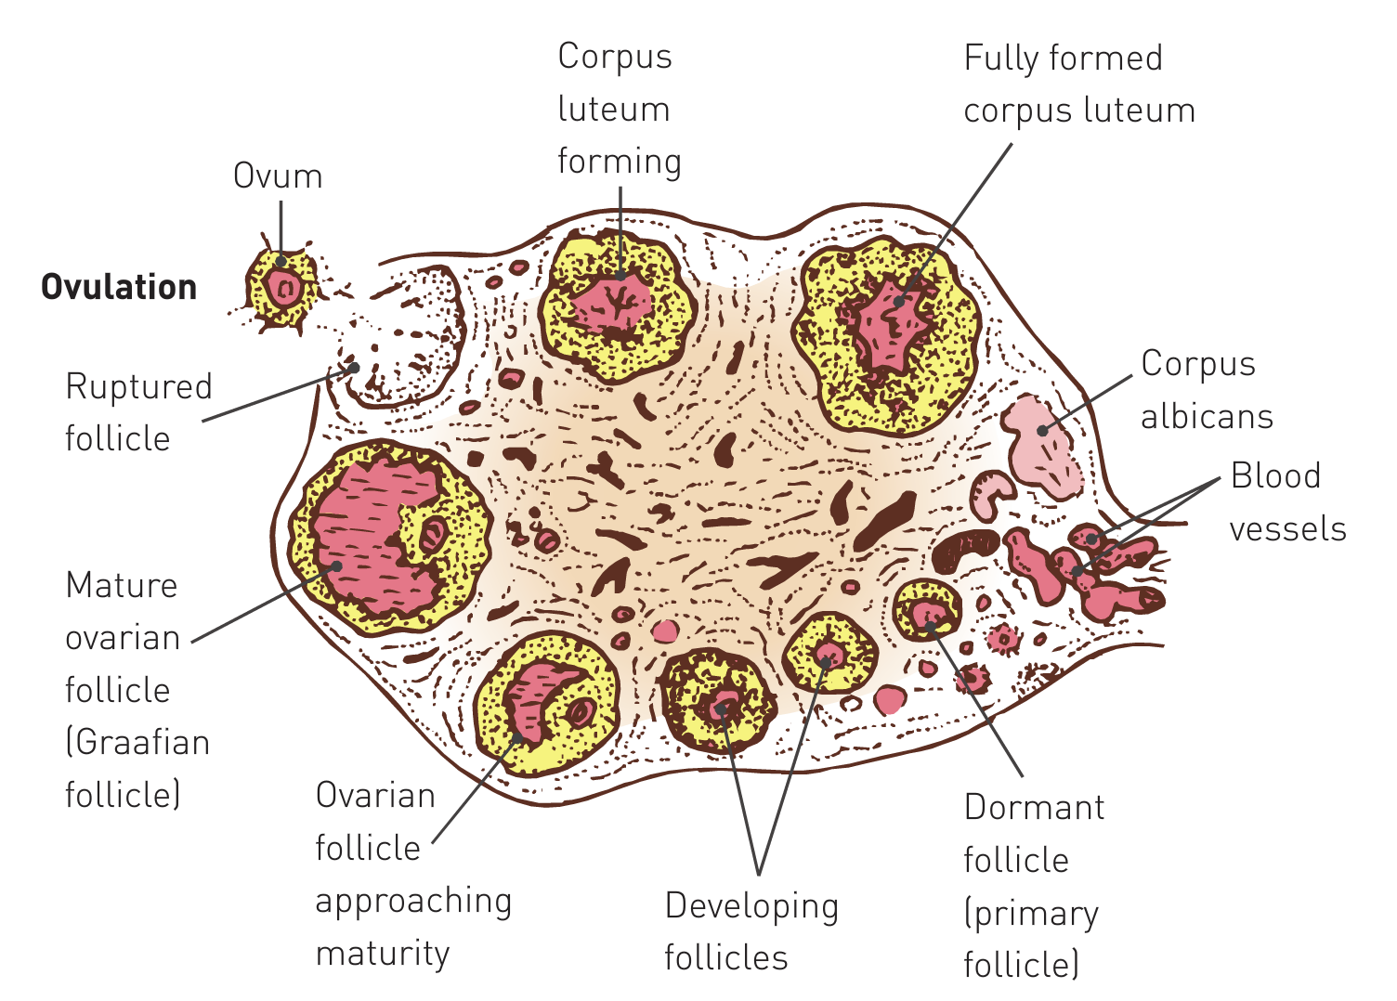
Ovarian Cycle

- The ovarian cycle is a series of events that take place within the ovaries
- Includes the maturation of an egg and its release into a uterine tube
- Development of follicles in the ovary and the formation of the corpus luteum
- Length of cycle is highly variable, depending on the individual and her circumstances
  - May range from 20-40 days, with an average of 28 days
- The ovarian cycle is commonly considered to be a 28-day cycle, though only 30% of women have a cycle 27/28 days in length
- At birth, female ovaries have ~400,000 immature eggs
- Formation of these eggs occurred before birth during foetal development
- Cells in ovary undergo many divisions but stop dividing before eggs are actually formed
- The immature eggs remain in a resting phase for many years
- Other cells within ovary surround each immature egg to produce a sphere composed of a single layer of cells – called a primary follicle

- When a female matures sexually (puberty) some primary follicles undergo further development
- Cells forming wall of primary follicle begin to enlarge and divide which creates a layer of cells around the developing egg
- Secretions of these cells create a fluid-filled space the forces the egg to the edge of the follicle – now referred to as a secondary follicle
- Several secondary follicles commence development in each cycle but usually only one completes development
- Others normally break down to be reabsorbed into the ovary
- As more fluid accumulates within follicle, it continues to enlarge and gradually moves towards the surface of the ovary
- On reaching the surface it produces a bulge, which looks like a swollen blister
- Now known as a mature follicle (once known as a Graafian follicle)
- Usually takes 10-14 days for a primary follicle to develop into a mature follicle

- When the mature follicle bursts, it expels the egg in a process called ovulation
- The open end of the uterine tube acts as a funnel over the ovary
- Beating cilia within the funnel create a current that sweeps the egg into the tube
- Usually only one follicle matures at a time, so only one egg is released
- Very occasionally, two or more follicles may burst at the same time releasing more than one egg
- Following ovulation, the ruptured follicle collapses and the blood within forms a clot
- Clot is gradually absorbed by remaining follicle cells, which enlarge and change colour to form a cream-coloured body, the corpus luteum
- Hormones that influence the development of the lining of the uterus are secreted by the corpus luteum
- If fertilisation has not occurred, the corpus luteum reaches its maximum development about 8-10 days after ovulation
- It then begins to degenerate into a fibrous mass of scar tissue, the corpus albicans which eventually disappears
- Another ovarian cycle begins – seems to be a matter of chance whether it occurs in the same ovary or the opposite ovary

- If fertilisation of an egg takes place and pregnancy follows, the corpus luteum continues to develop and the ovarian cycles cease
- Corpus luteum reaches peak of its development in about the third month of pregnancy
- Begins to degenerate after this, but degeneration is slow and it is still present in the ovary at childbirth
- Ovarian cycles usually resume only after breastfeeding of the baby has ceased

